Data Flow Diagram
Requirement Analysis
Date | 17 July 2026
Team ID | Not provided
Project Name | House Rent Management System (HouseHunt / RentEase)
Maximum Marks | 2 Marks

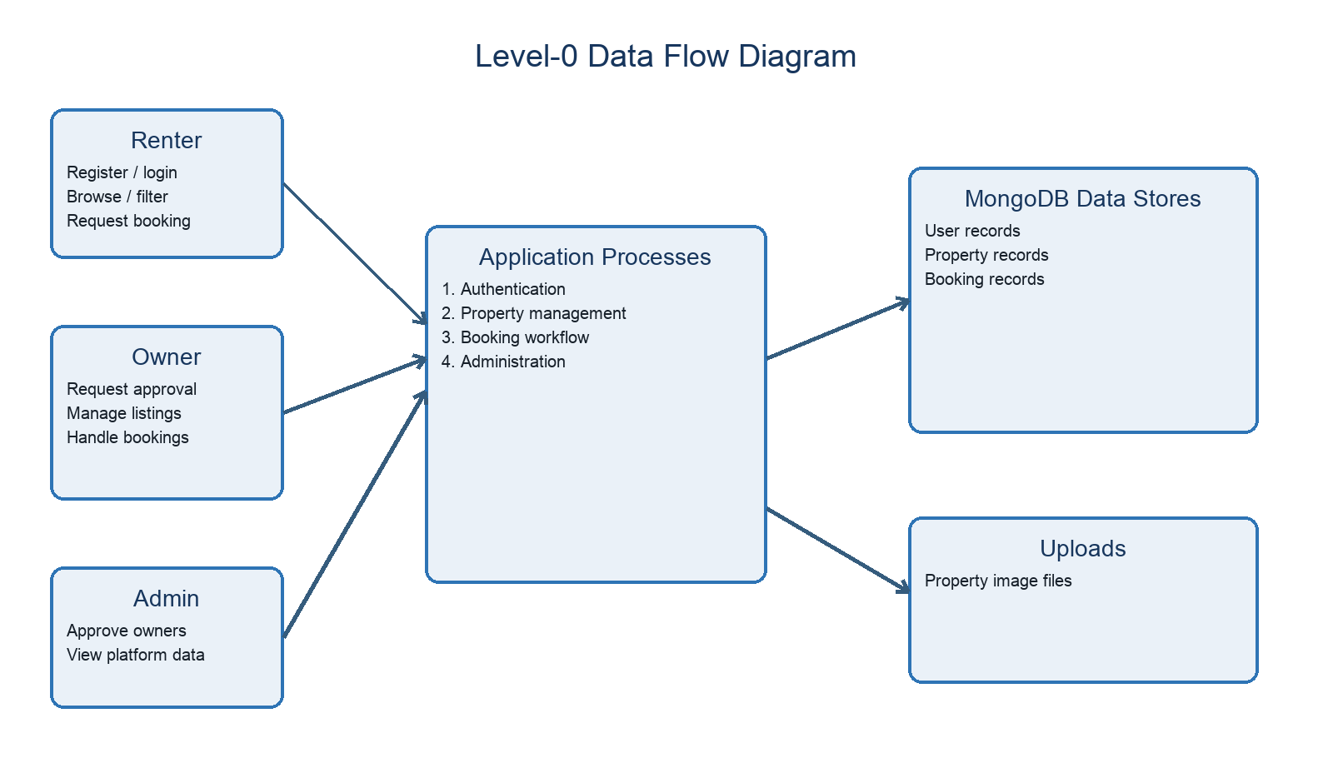
Figure 1. Level-0 data flow derived from the repository.

Flow Description
- A user registers or logs in through the React client.
- The Express API validates the request and JWT where required.
- Controllers read or write user, property, and booking documents in MongoDB.
- Property images are written to and served from the uploads directory.
- The API returns JSON that updates the relevant role dashboard.

